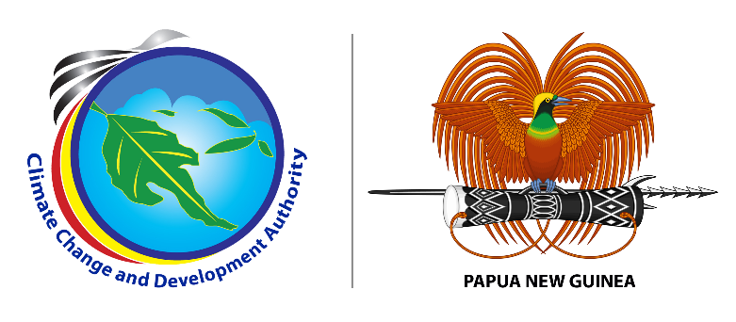

**MEDIA RELEASE**

**01 July, 2023**

**CCDA staff remain united to deliver**

The Management and Staff of Climate Change and Development Authority (CCDA) gathered in a small but significant feast ceremony on Friday (yesterday) in Port Moresby to reignite their team spirit to work. They were also joined by few representatives from development partners and partners from other agencies.

Acting Managing Director of CCDA William Lakain said staff members are critical assets of an organization because their skills, expertise, and execution capabilities are vital for achieving organizational goals, and ensuring the overall success and growth of the organization.

“CCDA as a young organization, I am delighted to see that the organization’s staff members are so dedicated to their work and for their cooperation. This is a good working culture and I am happy to provide the leadership they need along with the management so the organization delivers and progresses”, said Mr. Lakain.

“Despite recent allegations surrounding mismanagement issues at CCDA in the media, CCDA has made significant progress” sad Mr. Lakain.

“One progress is Climate Change Management Act (CCMA) 2021 amendment which is now set before the National Executive Council for Endorsement and for further tabling in Parliament in the next Parliament sitting.

“The amended CCMA provides for the regulation of carbon market in the country. This will also make way for revenue generation for the country through the sale of quantified carbon credits from climate change mitigation activities”, said Mr. Lakain.

“The revised CCMA also provides for the establishment of a National Climate Change Board which will provide overall direction in ensuring transparency and accountability of CCDA’s function. Besides. we have made a submission to the NEC for the setup of the Board pending for approval”, said Mr. Lakain

“These are significant progresses among other key progresses at CCDA under my one-year tenure as the Acting Managing Director. CCDA has a huge potential to deliver where steps as such are critical to empower the organization to implement the government’s climate change mitigation and adaptation priorities highly needed in the country by our people”, he added.

Mr. Lakain encouraged the management and staff of CCDA for their continued cooperation to ensure the organization is transformed to a state that is fully resourced to strengthen its coordination of climate change efforts for the people and the government of PNG.

###

**About us:**

Climate Change and Development Authority (CCDA) is the official Government entity in coordinating climate change efforts of Papua New Guinea. It coordinates all climate related policies, strategies and actions with the vision of being the leader in promoting climate resilience, low carbon growth and sustainable development in Papua New Guinea. Find out more at: [www.ccda.gov.pg](http://www.ccda.gov.pg)

**CCDA Media Contact:**

Mr. Samson Kupale

Communications Focal

Climate Change and Development Authority

Tel: 72641570 /77009763

Email: [samson.kupale@ccda.gov.pg](mailto:samson.kupale@ccda.gov.pg)

***Attached accompanying photos and captions:***

***IMG 001:*** *William Lakain- Acting Managing of Climate Change and Development Authority*

***IMG 002:*** *Climate Change and Development Authority Management and Staff (file photo)*