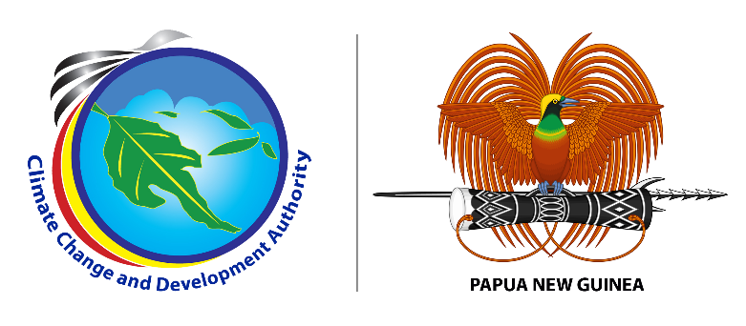

**MEDIA RELEASE**

**Thursday 13 July, 2023**

**CCDA conducts provincial capacity building workshop**

The Climate Change and Development Authority (CCDA) has kickstarted its provincial capacity building workshop today starting with West New Britian Province. The workshop aims to equip relevant sectors in the province understand and acknowledge each other’s active roles in the climate change space and re-affirm commitments to accessing resources to implement PNG’s Nationally Determined Contributions (NDCs) effectively.

NDCs are central components of the Paris Agreement on climate change. They are voluntary commitments that each country makes to reduce its greenhouse gas (GHG) emissions and adapt to the impacts of climate change.

During the opening, CCDA’s Acting General Manager for MRV and NC Division Ms. Debra Sungi highlighted the significance of the workshop, also highlighting the importance of national to sub-national policy alignment on climate action for West New Britian Province.

“This training aims to offer insights and opportunities for West New Britain Provincial Government to contribute to PNG’s achievement of emission reduction targets of the country’s Nationally Determined Contributions under the Paris Agreement.

“The training identifies different actors’ involvement in projects and program in the climate change space at the provincial level where we can further discuss experiences, challenges and gaps involved and strategies to maximize support for the provincial stakeholders”, said Ms. Sungi.

Ms. Sungi added that decentralization of CCDA’s coordination at the sub-national level through policy alignment including sub-national stakeholder capacity upgrade is a key step in implementing climate change mitigation and adaptation actions at the provincial level.

Other provinces to be covered under this capacity building program in the coming weeks include Milne Bay, New Ireland, Eastern Highlands and Western Highlands Province. For West New Britain Province, over fifteen participants from the Provincial Administration are participating in this workshop.

Caretaker Provincial Administrator of West New Britain Provincial Administration Mr. Roberth Dau acknowledged CCDA for running this workshop and for working closely with the provincial administration to ensure developments in the areas of climate change mitigation and adaptation are well coordinated going forward.

###

**About us:**

Climate Change and Development Authority (CCDA) is the official Government entity in coordinating climate change efforts of Papua New Guinea. It coordinates all climate related policies, strategies and actions with the vision of being the leader in promoting climate resilience, low carbon growth and sustainable development in Papua New Guinea. Find out more at: [www.ccda.gov.pg](http://www.ccda.gov.pg)

**CCDA Media Contact:**

Mr. Samson Kupale

Communications Focal

Climate Change and Development Authority

Tel: 72641570 /77009763

Email: [samson.kupale@ccda.gov.pg](mailto:samson.kupale@ccda.gov.pg)

***Accompanying picture and caption.***

*IMG 001 Participants at the workshop posing for a group photo.*