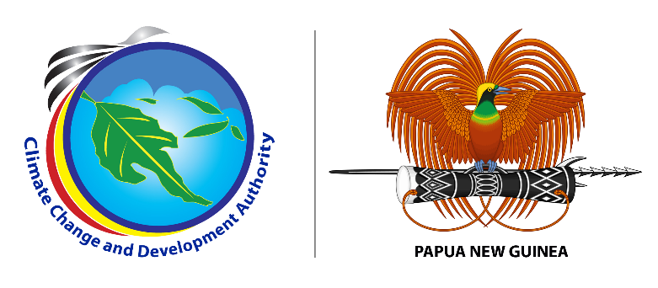

**MEDIA RELEASE**

**15 June, 2023**

**CCDA rolls out school climate change awareness**

The Climate Change and Development Authority (CCDA) has kickstarted its school climate change awareness beginning of this month as a lead up activity towards the Second National Climate Summit in September. The program targets secondary schools in the National Capital District (NCD) and Central Province, aimed at driving awareness of climate change in schools.

CCDA’s National Communication Acting Manager Erick Sarut said 22 secondary-level schools will be visited in June and July to carry out awareness about climate change.

“The climate emergency is a race we are losing, but is also a race we can win through education and awareness”, said Mr. Sarut.

“The secondary awareness program is to educate our young, future leaders on what actions we should take to address the climate emergency because we are the first generation to feel the impacts of climate change and the last generation that can do something about it,” said Mr. Sarut.

“By raising awareness about climate change, students can develop a deep understanding of the challenges they will face and the importance of taking action to mitigate and adapt to climate change” he added.

Schools visited by CCDA so far includes Gerehu Secondary School, St. Charles Lwanga Secondary School, Jubilee Catholic Secondary School and Don Bosco Technical Secondary School. There are other 18 schools both in NCD and Central Province to be visited to deliver similar awareness this month.

The school awareness program is also a key step in raising public awareness about the upcoming Second National Climate Change Summit. This is an important calendar event for CCDA to be hosted from the 12-13 September 2023 in Port Moresby.

During the school visits, students and staff were informed of how they can participate in the Summit. One is through an Inter-School Debate Competition. The Competition which will be held on the 11th of September 2023, for Secondary Schools in NCD and two schools in Central Province to register to participate. The Inter-School Debate will be centered around the theme; “Promoting Climate Justice and Social Inclusion.”

“So far from the school visits, the feedback from the students and staff have been positive. The positive feedback and interest from the students is an indication of how important the awareness on climate change means to them and how programs like the school debate competition are crucial to their learning”, said Mr. Sarut.

“On behalf of the Management of CCDA, I thank officers from CCDA who are also the members of the Summit Organizing Committee for leading this awareness. I also thank the school administrations for accepting our invitation and giving us time to visit their School to deliver the awareness,” concluded Mr. Sarut.

###

**About us:**

Climate Change and Development Authority (CCDA) is the official Government entity in coordinating climate change efforts of Papua New Guinea. It coordinates all climate related policies, strategies and actions with the vision of being the leader in promoting climate resilience, low carbon growth and sustainable development in Papua New Guinea. Find out more at: [www.ccda.gov.pg](http://www.ccda.gov.pg)

**CCDA Media Contact:**

Mr. Samson Kupale

Communications Focal

Climate Change and Development Authority

Tel: 72641570 /77009763

Email: [samson.kupale@ccda.gov.pg](mailto:samson.kupale@ccda.gov.pg)