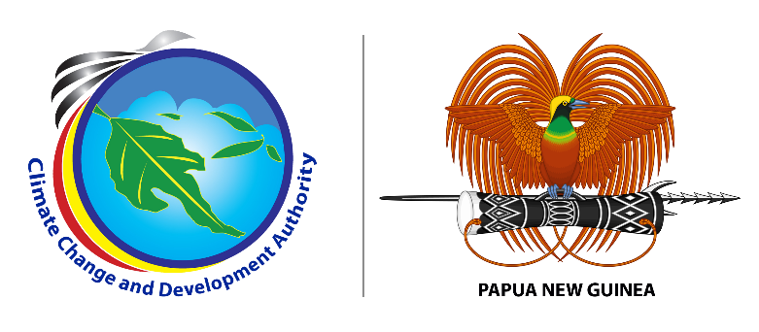

**MEDIA RELEASE**

**30 June, 2023**

**19 Officials Receive Certificate on Project Management**

Nineteen officials from government and non-government organizations (NGOs) were awarded certificates today for actively participating in a six weeklong online Dedicated Mentoring Program (DMP) held from April – June 2023. The DMP aimed to train government officials across different sectors on the development of project concept notes and funding proposals to access international climate finance through the Green Climate Fund Mechanism to fund Papua New Guinea’s climate actions.

The participants also participated in a five weeklong Green Growth Fellowship Program (GGFP) held from May – June 2023. The GGFP aimed at providing support to Climate Change and Development Authority (CCDA) and relevant national and provincial government staff in providing green growth policy advisory support, including low-carbon growth and sustainable development advice.

Acting Managing Director of CCDA William Lakain was Chief Guest at the awards ceremony, congratulated the participants and described both programs as critical for broadening their knowledge and skills in developing climate finance projects, and green growth policy interventions towards a low carbon growth in Papua New Guinea.

“These two programs are very important and should be supported into the future as it will greatly improve the knowledge and skills of government officials on key areas such as developing project concept notes and providing policy advisory support on low carbon growth and sustainable development”, said Mr. Lakain.

The participants were also the first to receive their certificates under a tripartite Memorandum of Understanding (MoU) between Global Green Growth Institute (GGGI), Climate Change and Development Authority with support from the Department of Foreign Affairs and Trade (DFAT) and the three Universities; the University of PNG (UPNG), University of Technology and the University of Natural Resources and Environment (UNRE) to run the programs.

DFAT Australia was represented at the ceremony by Mr Nic Jonsson, the Counsellor Economics at the Australian High Commission in Port Moresby. Mr Jonsson in his opening remarks said Australia was very proud to fund the DMP and GGFP knowing the value add it will make to build the capacity of the Government of PNG and NGOs to access international climate finance and render quality climate change policy advice. He thanked GGGI for its role as the delivery partner in collaboration with UPNG.

Ms. Priscilla Pep, one of the participants expressed that these two programs are very important because currently, workplaces are becoming more competitive as new ideas or skills are introduced.

“These programs have helped us upscaled our knowledge in building and managing projects at different scales be it private or public sectors”, said Ms. Pep.

CCDA’s Acting Managing Director William Lakain acknowledged the support of GGGI in this endeavor. He also thanked the Australian High Commission in accommodating this program through funding support under the PNGAus Climate Change Partnership. Mr. Lakain further acknowledged the University of Papua New Guinea for running these important programs.

###

**About us:**

Climate Change and Development Authority (CCDA) is the official Government entity in coordinating climate change efforts of Papua New Guinea. It coordinates all climate related policies, strategies and actions with the vision of being the leader in promoting climate resilience, low carbon growth and sustainable development in Papua New Guinea. Find out more at: [www.ccda.gov.pg](http://www.ccda.gov.pg)

**CCDA Media Contact:**

Mr. Samson Kupale

Communications Focal

Climate Change and Development Authority

Tel: 72641570 /77009763

Email: [samson.kupale@ccda.gov.pg](mailto:samson.kupale@ccda.gov.pg)

***Attached picture caption:***

**IMG 4510:** Officials with their certificates at the Drill Hall, University of Papua New Guinea, Main Campus, Port Moresby.

*Additional pictures and raw footages can be accessed via link below:* [*https://drive.google.com/drive/folders/1d3qwIaepRs6mMx4BOQVpeC7BBCDHT6-2?usp=sharing*](https://drive.google.com/drive/folders/1d3qwIaepRs6mMx4BOQVpeC7BBCDHT6-2?usp=sharing)