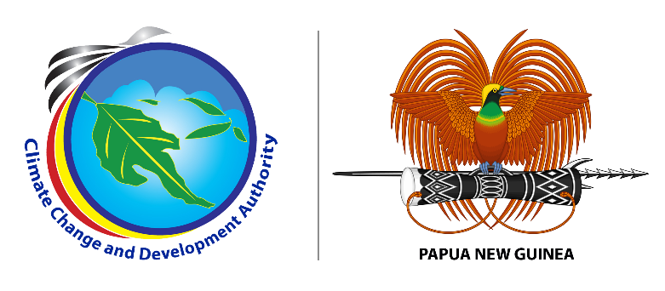

**MEDIA RELEASE**

**17 May, 2023**

**Workshop held to Strengthen National Reporting Systems for Climate Action**

An inception workshop held in Port Moresby today centred on strengthening the country’s (PNG) systems for effective reporting on climate actions. Climate reporting is an important tool for promoting transparency, accountability and for informed climate actions.

Led by Climate Change and Development Authority (CCDA) with technical support of the Food and Agriculture Organization of the United Nations (FAO), the workshop was a key step under phase two of PNG’s Capacity Building Initiative for Transparency (CBIT) project.

The CBIT project was established to build institutional and technical capacity for international climate reporting under the Enhanced Transparency Framework (ETF) of the historical Paris Agreement on climate change signed in 2015 to keep global temperature below two degrees Celsius.

CCDA’s General Manager of MRV and National Communication Division Debra Sungi explained that under the ETF, countries are required to establish robust measuring, reporting, and verification (MRV) systems and to communicate their efforts to the United Nations Framework Convention on Climate Change (UNFCCC) of which PNG is a party.

She said that in this regard, the CBIT project has significantly improved the institutional capacity for ETF in PNG in phase one. Ms. Sungi added that CCDA is pleased to collaborate with FAO on the second phase of the project, which will further enhance the capacity for ETF and enable the country to meet its reporting requirements under the Paris Agreement.

The workshop was attended by stakeholder participants from the government, private sector, the civil society organizations, academia and others. Participants also had the opportunity to discuss and understand data sharing and reporting systems, capacity for ETF data collection, management and analysis which can be reliably communicated.

CCDA’s Acting Managing Director William Lakain said PNG as a country is committed to fulfilling its international climate change obligations under the Paris Agreement of which capacity building workshops as this will enable PNG to be on par in meeting its international climate change reporting obligations.

“I express my gratitude towards our development partners and stakeholders from both the public and private sectors for supporting CCDA through the consultation process of the PNG CBIT Phase 2 project”, said Mr. Lakain.

Head of the FAO in PNG Mr. Bir Mandal expressed that FAO is committed to supporting the Government of PNG in enhancing its institutional and technical capacity for reporting under the ETF. Mr. Mandal added that the second phase of the CBIT project will build upon the success of the first phase and will ensure that PNG is on track to meet its reporting requirements under the Paris Agreement.

Highlight of today’s workshop was the launching of three significant climate change policy documents; the NDC AFOLU Mitigation Plan 2022-2025, the NDC Energy Mitigation Plan 2022-2025 and the GHG Improvement Plan 2022-2024.

###

**About us:**

Climate Change and Development Authority (CCDA) is the official Government entity in coordinating climate change efforts of Papua New Guinea. It coordinates all climate related policies, strategies and actions with the vision of being the leader in promoting climate resilience, low carbon growth and sustainable development in Papua New Guinea. Find out more at: [www.ccda.gov.pg](http://www.ccda.gov.pg)

**CCDA Media Contact:**

Mr. Samson Kupale

Communications Focal

Climate Change and Development Authority

Tel: 72641570 /77009763

Email: [samson.kupale@ccda.gov.pg](mailto:samson.kupale@ccda.gov.pg)

***Accompanying photos and captions:***

**IMG 001:** Stakeholder participants posing for a photo during the workshop with the three launched policy documents.

**IMG 002:** Acting Managing Director of Climate Change and Development Authority William Lakain giving his opening remarks.