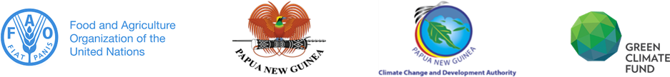
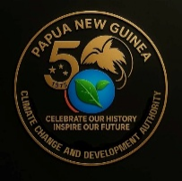
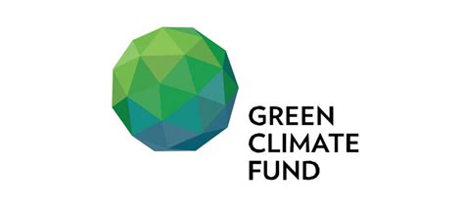

MEDIA RELEASE

Port Moresby, 18 November 2025 – Papua New Guinea, through the Climate Change and Development Authority (CCDA) and the United Nations Food and Agriculture Organization (FAO) formally signed a Results Based Payment (RBP) Transfer Agreement for the Green Climate Fund (GCF) results-based payment of USD 63.4 million (PGK K259.8 million).

The funding was approved by the GCF Board during its forty-second Board Meeting hosted at the APEC Haus from 30 June – 3 July this year. Simultaneously, the GCF also signed a Funded Activity Agreement (FAA) with the FAO, a GCF-accredited entity (AE), to facilitate and disburse the RBP in accordance with GCF guidelines and policies.

The Transfer Agreement provides the framework for the implementation and funding of activities captured under Papua New Guinea’s National REDD+ Strategy, the PNG Enhanced Nationally Determined Contribution 2020 and sets into operation the signed FAA by FAO and GCF. In accordance with the REDD+ Benefit Sharing Guidelines (2023), 60 per cent of the funding will be allocated for supporting the sustainable livelihood of communities.

The signing essentially allows for the transfer of funding from GCF to FAO as the Accredited Entity to coordinate the implementation of programmes under the fund. CCDA as the government’s principal agency responsible for leading national efforts in climate change, will provide the strategic oversight to ensure programmes are aligned with Papua New Guinea’s priorities.

The CCDA Acting Managing Director Ms. Debra Sungi acknowledged GCF for the funding and expressed a desire to see the implementation of programmes to kickstart in the new year.

“Papua New Guinea is privileged receive the landmark funding of USD 63.4 million for our efforts in protecting our forests to reduce the 17 million metric tons of CO2-equivalent GHG emissions from 2014 to 2016 and it is an achievement we must all be proud of. It is a testament of our collective efforts and I want to thank key government agencies like PNG Forest Authority, development partners like FAO and local communities who have contributed to conserving and protecting our natural resource so that we benefit from them. Now that we have signed the agreement after going through the lengthy process of negotiating the terms of the agreement, all activities must commence without delay for the benefit of our people in the local communities and the country as a whole,” asserted Ms. Sungi.

Dr. Kachen Wongsathapornchai, Head of Office at FAO-PNG, stated: “Today’s signing marks a major step forward for Papua New Guinea’s climate leadership. The USD 63.4 million Results-Based Payment from the Green Climate Fund is not a payment for promises, but for proven results—recognizing Papua New Guinea’s success in reducing emissions through forest protection. FAO is honoured to support the Government, through CCDA, in translating this achievement into lasting benefits for communities, livelihoods, and globally significant forests, while ensuring transparency, accountability, and national ownership at every step.”

Photograph 1 Caption: The Head of Office at FAO-PNG Dr. Kachen Wongsathpornchai (left) and Climate Change and Development Authority Acting Managing Director Ms. Debra Sungi photographed at the signing of the Results Based Payment Transfer Agreement.

Photograph 2: The Head of Office at FAO-PNG Dr. Kachen Wongsathpornchai and his technical team pictured with Climate Change and Development Authority Acting Managing Director Ms. Debra Sungi and staff after the signing of the Results Based Payment Transfer Agreement.

APPROVED FOR IMMEDIATE RELEASE

